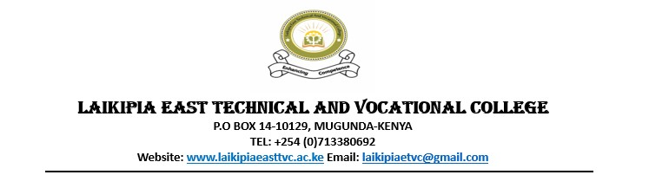

**LEVEL 5 TERM 2 CAT ASSESSORS GUIDE**

1. List 4 types of computer maintenance tools

* Compressed Air Duster
* Blower
* screwdrivers
* Antistatic Cleaning Brushes
* Isopropyl Alcohol and Cleaning Wipes
* Vacuum Cleaner with ESD-Safe Attachments
  + - Award 1 mark for each

1. State 4 types of computer maintenance

* *Corrective maintenance*
* *Adaptive maintenance*
* *Perfective maintenance*

*Preventive maintenance*

* + - Award 1 mark for each

1. Define the following terms

**RAM (Random Access Memory)**

* RAM is a type of volatile memory used in computers and other devices to store data that is being actively used or processed.

**ii. ROM (Read-Only Memory)**

* is a type of non-volatile memory used in computers and other devices to store firmware or software that is rarely changed.

**iii. CMOS (Complementary Metal-Oxide-Semiconductor)**

* CMOS often refers to a small amount of battery-powered memory that stores BIOS settings, including system time and hardware configuration.

**iv. BIOS (Basic Input/Output System)**

* **Definition:** BIOS is firmware used to perform hardware initialization during the booting process and to provide runtime services for operating systems and programs.
  + - Award 1 mark for each

1. Differentiate between a cooling fan and a heat sink

* *Cooling Fan: A cooling fan is an active cooling component that uses rotating blades to generate airflow, which helps dissipate heat from a heat sink or directly from electronic components like the CPU or GPU.*
* *Heat Sink: A heat sink is a passive cooling component made of metal (usually aluminum or copper) with fins that increase surface area to dissipate heat away from electronic components.*

Award 2 mark for each

1. Explain two factor that make the CPU faster

* **Number of Cores**: Modern CPUs have multiple cores, each capable of executing its own instructions simultaneously.
* Cache Size

Award 2 mark for each

1. State 3 functions of buses

* Power Distribution
* Control Signal Distribution
* Addressing
* Data Transfer
  + Award 1 mark for each

1. What is a data cable giving 3 examples
   * A data cable is a type of cable used to transmit information between devices.SATA,USB,Ethernet Etc
   * Award 3 marks
2. What is a computer port and give 2 examples

* computer port is a physical or virtual interface on a computer system used for connecting external devices, peripherals, or communication networks. Eg USB port, Audio ports, video ports, etc

1. State 3 types of expansion bus types

PCI

PCIe

AGP

* + Award 1 mark for each

1. Explain two types of processor sockets

* PGA is a processor socket type where the pins are located on the processor itself. These pins make direct contact with the corresponding holes in the socket. PGA sockets are commonly found in older systems and certain server configurations.
* LGA (Land Grid Array)LGA is a processor socket type where the pins are absent on the processor; instead, the socket contains pins that make contact with pads on the underside of the processor.
* Award 1 mark for each